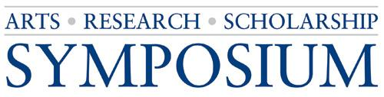
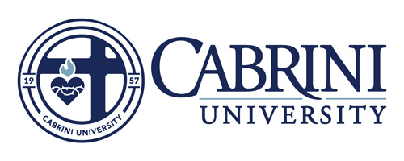
Academic Symposium Presentation Proposal

Deadline to Submit to Faculty: April 1, 2020

All Cabrini University students are invited to submit presentation proposals for the annual Arts, Research, and Scholarship Symposium on Tuesday, April 28, 2020.
Please complete this form, save the file as “firstname_lastname.docx”, and email it as an attachment to your faculty sponsor.

Student Name: _________________________________________________________________
Student Email: __________________________________________________________________
Student’s Primary Major Department (Biology, Sociology, History, etc.): _____________________
Names and emails of All Additional Presenters (if any): __________________________________
______________________________________________________________________________
Faculty Sponsor: ________________________________________________________________
Title of Work:
______________________________________________________________________________
Preference of Venue
(please type either: poster, oral presentation, performance, or artwork): _____________________
Graduate students only: Present online or face-to-face: _____________________

IRB Approval
Are you using active, human participants? Yes or No ________

If Yes, please consult with your faculty sponsor and complete the IRB Protocol Review Form. Include the IRB Protocol Review Approval Number here: _______________

Are you an undergraduate or graduate student: ________ (UG or GR)

Abstract
All proposals require an abstract of no more than 250 words and will be used verbatim in the online program. The abstract should describe the specific purpose of the project (the research question to be answered), why it is important, how it was developed (methods used), and results. If the results are not yet available, indicate that the results will be available at the Symposium.

Faculty Approval – to be completed by faculty sponsor
Faculty Sponsors, when you receive this form, please review it and, if necessary, edit the text of the abstract, then indicate your approval by initialing this form, re-saving it and emailing it to ARSsymposium@cabrini.edu by April 8, 2020. Also, please indicate if you believe this work warrants consideration for publication in one of Cabrini University’s Research Journals.

Faculty Initials: _______
I believe this work is eligible to be considered for publication in one of Cabrini University’s Research Journals (Undergraduate or Graduate). ____Yes ____No
Faculty Mentors: If you checked Yes above, please advise your students that their papers/research manuscripts or artwork must be submitted to you no later than Friday, May 15, 2020. You are then responsible for forwarding the papers to the committee chairs upon receipt. The peer-review process takes place beginning June 2020 by the Editorial Board.

Updated: March 19, 2020

