Cabrini Day 2019
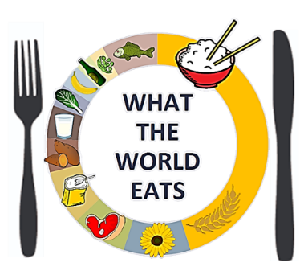 | Food Matters  Presentation Forum to be held:  November 12, 2019  Dixon Center  10:00 am – Noon | 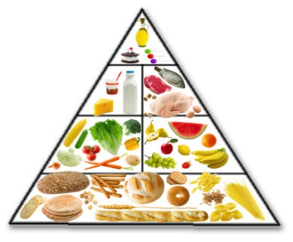
Submission Deadline: 5 PM, Friday, October 25, 2019
This year, we will celebrate Cabrini Day on Tuesday, November 12, 2019 with a series of events expressing the theme, “Food Matters.” The Cabrini Day 2019 Committee has chosen this theme to embrace the Cabrinian tradition of fostering human dignity through the fulfillment of basic needs. Here are some possible topics to consider:
Here are some possible topics to consider:
- What are the philosophical roots of food traditions?
- How do religion and spirituality play a role in food matters?
- How is child development affected by food insecurity?
- What are the psychological effects/motivations of food?
- What are the cognitive processes associated with nourishment?
- How is food related to cultural expression and tradition?
- From an ethological perspective, what can we learn from different animal species about food?
- How did different waves of immigrants affect American food traditions?
- What roles do social networks play in food matters?
- What forms of lifestyle, exercise, and nutrition enhance healthy resilience?
- How can we prepare students to appreciate the role food has in their daily lives?
- How do our students express their individuality and identity through food?
- What are genetically modified organisms? How are they made and are they safe? What are the concerns with their use?
- What are the implications of biofuel production, on the climate vs food security?
- What are the potential ramifications of climate change on the global food chain?
- Ecological footprint: what is it? Vegetarian/vegan/local omnivore?

Other topics
- Food recovery/food waste
- Food manufacturing and distribution
- Genetically modified organisms (GMOs)
- Food insecurity
- Food marketing/Advertisements
- Nutrition/Food availability
- Food cupboard/Food pantries
- Fair trade
- Water quality and availability: potable and agricultural
- Immigration, cultural expression and food
- Childhood obesity/Childhood hunger
- School lunches
- Public policy (e.g. soda tax)
- Food and climate change
- Global food issues
- Popular diets
- Food inequities and social justice

Programs could include: Poster presentation, artistic exhibits or performances (visual, musical, theatrical, or dance), conversations, multi-media presentation or any other medium for affirming the role of food in affirming human dignity.
To participate in the Cabrini Day Presentation Forum, please complete this form, save it with your first and last name, and email it as an attachment to CabriniDay@cabrini.edu
Your Name:
Your Email:
Your Phone Number:
Names & Email Addresses of Any Additional Presenters:

Your Affiliation - State the name of the course, club, athletic team, staff office, or department that you are representing in this presentation:

Your Presentation Mentor - State the name of your course instructor, club advisor, athletic coach, or mentor who is working with you on this presentation:

Title of Your Presentation - State the name of your presentation as you would like it to appear in the event program (you must supply a title):

Identify Your Presentation Format (poster, performance, artwork, activity, multimedia, demonstration, or other; if other, please describe):

Will you need electricity for your presentation (e.g., to power a laptop)?

Please list additional needs for your presentation:

Institutional Review Board (IRB) approval is required if human subjects are participating in the study.
IRB requirements and details are available at www.cabrini.edu/IRB.
Did this proposal receive IRB approval? Yes ☐ No ☐
IRB Approval Not Needed ☐
IRB Approval Received ☐ IRB Number:

A Special Message to Faculty Mentors
The Cabrini Day Committee appreciates the role of the faculty in mentoring students to present on Cabrini Day. Please have your students send their proposals to CabriniDay@cabrini.edu. Thanks!

Submission Deadline: 5 PM, Friday, October 25, 2019
- Submit your completed proposal form by email to CabriniDay@cabrini.edu Please put your name in the subject line of the email.
- All student presenters participating as part of a course must discuss their presentation with their faculty mentors for approval prior to the event.
Please email any questions or comments to David Madway at dem74@cabrini.edu.

